Topics: Confidence Intervals

- For each of the following statements, indicate whether it is True/False. If false, explain why.

- The sample size of the survey should at least be a fixed percentage of the population size in order to produce representative results.
- False, It is not solely dependent on the fixed percentage of the population, There are other measures that need to be considered while taking sampling such as stratified sample, independent sample, random sample etc.

- The sampling frame is a list of every item that appears in a survey sample, including those that did not respond to questions.
- True

- Larger surveys convey a more accurate impression of the population than smaller surveys.
True but the sample must be random and independent and must not contain any bias i.e it should be representative of the whole population.

- PC Magazine asked all of its readers to participate in a survey of their satisfaction with different brands of electronics. In the 2004 survey, which was included in an issue of the magazine that year, more than 9000 readers rated the products on a scale from 1 to 10. The magazine reported that the average rating assigned by 225 readers to a Kodak compact digital camera was 7.5. For this product, identify the following:

- The population
- Everyone who read the magazine and tried the product.
- The parameter of interest
- The population average rating of the product.
- The sampling frame
- Everyone who were eligible for the review of products via the magazine.
- The sample size
- 9000 and more
- The sampling design
- They didn’t specify it but we can say that it might have been “census”
- Any potential sources of bias or other problems with the survey or sample
- They gave only 225 responses average rating, they might have only selected people with good to average review or selected positive half of the reviews.
- The sample space might not include people who don’t use their products before which will create a bias.

- For each of the following statements, indicate whether it is True/False. If false, explain why.

- If the 95% confidence interval for the average purchase of customers at a department store is $50 to $110, then $100 is a plausible value for the population mean at this level of confidence.
- True as confidence interval is used to calculate population mean and 100 lies in that interval.

- If the 95% confidence interval for the number of moviegoers who purchase concessions is 30% to 45%, this means that fewer than half of all moviegoers purchase concessions.
- True Given the 95% confidence interval of 30% to 45%, it does provide an indication that the true proportion of moviegoers who purchase concessions is likely to be within that range. Therefore, the statement "this means that fewer than half of all moviegoers purchase concessions" is a plausible inference because 45% is less than half (50%). While it doesn't provide an exact value, it does suggest that it's more likely that fewer than half of all moviegoers purchase concessions based on the given confidence interval.

- The 95% Confidence-Interval for μ only applies if the sample data are nearly normally distributed.
- False there needs to be certain other conditions such as sample size should be sufficiently large, skewness will be minimum(practically from -0.5 to +0.5), sample should be random and independent and should represent the whole population.

- What are the chances that ?

- ¼
- ½
- ¾
- 1

- B ½ as it can be greater or it can be smaller.

- In January 2005, a company that monitors Internet traffic (WebSideStory) reported that its sampling revealed that the Mozilla Firefox browser launched in 2004 had grabbed a 4.6% share of the market.

- If the sample were based on 2,000 users, could Microsoft conclude that Mozilla has a less than 5% share of the market?
- Its hard to tell as we don’t have any confidence interval.
- WebSideStory claims that its sample includes all the daily Internet users. If that’s the case, then can Microsoft conclude that Mozilla has a less than 5% share of the market?
- Yes Microsoft can say that now because they have already done all the statistics in this case.

- A book publisher monitors the size of shipments of its textbooks to university bookstores. For a sample of texts used at various schools, the 95% confidence interval for the size of the shipment was 250 ± 45 books. Which, if any, of the following interpretations of this interval are correct?

- All shipments are between 205 and 295 books.
- False we only have the data that population mean is between 205-295

- 95% of shipments are between 205 and 295 books.
- False we are only 95% sure that the population mean lies in between that range.

- The procedure that produced this interval generates ranges that hold the population mean for 95% of samples.
- True

- If we get another sample, then we can be 95% sure that the mean of this second sample is between 205 and 295.
- False every sample may produce different results and are independent of each other so we cant predict that.

- We can be 95% confident that the range 160 to 340 holds the population mean.
- False the range is 205-290 for 95% confidence

- Which is shorter: a 95% z-interval or a 95% t-interval for μ if we know that σ =s?

- The z-interval is shorter
- The t-interval is shorter
- Both are equal
- We cannot say
- Z-interval is shorter because when we use the zvalue and t value estimation, t value has an extra variable namely sqrt n which increases the value of t interval margin of error.

Questions 8 and 9 are based on the following: To prepare a report on the economy, analysts need to estimate the percentage of businesses that plan to hire additional employees in the next 60 days.
n=Z^2⋅p⋅(1−p)​/ E^2
with this we can calculate sample size n
->
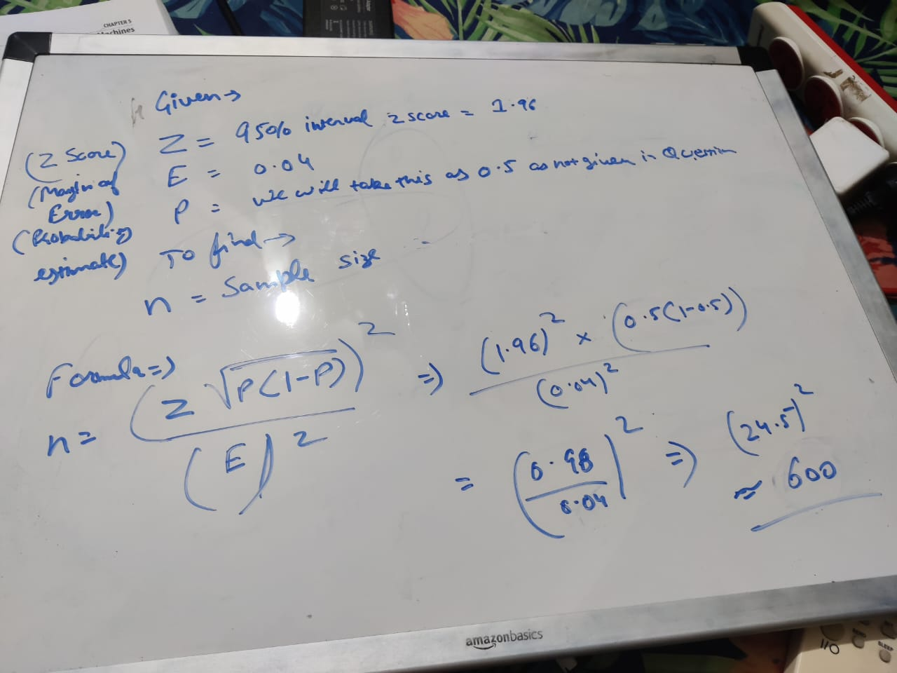
- How many randomly selected employers (minimum number) must we contact in order to guarantee a margin of error of no more than 4% (at 95% confidence)?

- 600
- 400
- 550
- 1000

- 600
According to the formula n=Z^2.p.(1-p)/E^2
Z= zscore for confidence interval(95% is 1.96)
P=approx. value would be 0.5, this means, this is estimate of business hiring employees.
E=Margin of error =0.4
So-> (1.96^2)*0.5*0.5/0.4^2
=600
- Suppose we want the above margin of error to be based on a 98% confidence level. What sample size (minimum) must we now use?
We will just change the Confidence value for z score
So the new value will be->
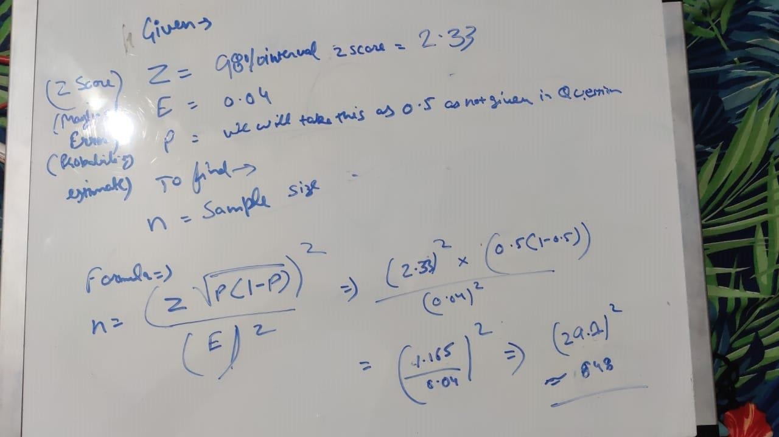
- 1000
- 757
- 848
- 543

- 848

